241/1
History and
Political education
Paper 1
2024
1 hour 40 mins

BSR JOINT EXAMINATIONS – 2024

UGANDA CERTIFICATE OF EDUCATION

HISTORY AND POLITICAL EDUCATION

Paper 1

1 HOURS 40 MINUTES

INSTRUCTIONS TO CANDIDATES:

This paper consists of sections A and B. It has four examination items

Section A is compulsory

Answer one item from section B

Answer three examination items in all
three items.

Any additional item answered will not be scored.

All responses must be written in the answer sheet(s) provided.

Turn Over

SECTION A
Answer all items

Item I:
A certain investor has requested for land of the local heritage site to construct a factory. He argues that his factory will promote economic growth and development of both the community and the country at large. The local leaders have accepted the investor’s request as a way of transforming the lives of their local people. However, the local people have totally rejected the proposal and have organised a strike if local leaders giveaway this land.

Support material
Aerial view of Uganda martyrs basilica Namugongo in Uganda.
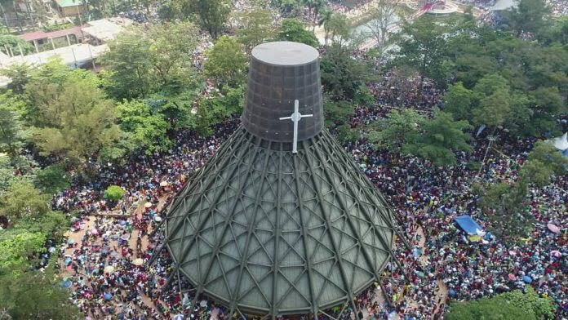

Task:
Defend the local people

Item II:
A certain village in Uganda has got new migrants from a neighbouring country. The village chairman has allocated them land where they can live peacefully. However, the local people are opposing this and threaten to overthrow the chairman. They are saying that these people come with many diseases and they exert a lot of pressure on local resources such as water, land, food, etc. Now the village members have put pressure on the chairman to expel the migrants very
fast.
Support material
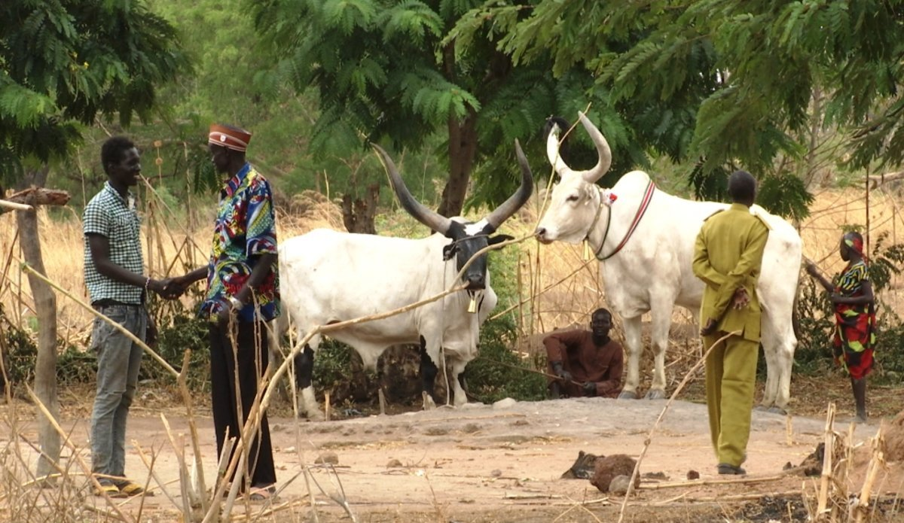
Photo used in a pre-migration conference organised by UNMISS to reduce tensions between farmers and cattle owners in South Sudan on 1st March 2018
Task; Convince the village members to support their chairman

SECTION B
Answer one item in this section

Item III:
A certain group of missionaries have come to your village and have requested the chairman to allocate them land to construct a hospital for the community. The chairman has organised a village meeting to share the missionaries’ proposal with the community members and if it goes through, they provide a site for the construction of the hospital. Many village members however are in opposition of giving missionaries free land. They argue that the hospital will not provide free medical services after all. These people argue that hospitals that were built by the earliest missionaries in Uganda were only built to serve their selfish interests and therefore, they have no trust that this hospital will provide free services.

Task. Support the village members argument

Item IV:
While a certain grandfather was listening to a certain political program on a given radio station on Monday, he heard one of the panelists using the concepts of nation and state differently. When time came for making phone calls on the program, he called to educate the panelist that the two concepts mean the same thing. Unfortunately, he was confused the more when the program moderator told him he was the one in wrong and not the panelist. Electricity went of before the moderator was done with responding to him.

Task: Sensitise the grand father

DEVELOPED BY BAGUMA SSENTAMU RICHARD

For facilitations and other resourceful books and handouts, contact him on 0750025446/0784114269

